Quality Plan

Loyola Student Center Enrollment System

1. Introduction
The Quality Plan Document for the Loyola Student Center Enrollment System will establish the activities, processes, and procedures for ensuring a quality standard or features upon the implementation of the system. The purpose of this quality plan is to:
- Ensure quality is planned
- Define how quality will be managed
- Define quality assurance activities
- Define quality control activities

This Loyola Student Center Enrollment System Quality Plan defines how the project team will support, communicate and implement project quality practices for the system to be developed for the client. The Project Developers will accomplish the following objectives for the System to be developed which is Loyola Student Center Enrollment System:

- Outlines the purpose & scope of quality activities
- Defines roles and responsibilities for quality management activities
- Defines acceptable quality standards
- Defines how quality will be planned and managed
- Defines quality assurance (QA) activities
- Defines quality control (QC) activities
- Defines acceptable quality standards

2. Project Contractual Information

Project: | Project LSC Enrollment System
Project Number:
Programme Co-ordinator: | Ms. Joan Limos, LSC Board of Director
Principal Investigators(s): | Name(s) and full details, i.e. address etc., of PI(s) with contractual responsibility

3. Scope of Work and Quality Objectives

Scope of work: | Improve the current website
Reference: | http://projects2.apc.edu.ph/wiki/index.php/Project_-_LSC_-_104#Scope_of_Work
QA Requirement: | - The website should have a simple and professional design, the colors that will be use should contrast well and the text is big enough to read clearly.  - Has a user-friendly navigation that can help the user find the relevant content of the website, the navigation should be consistent from page to page to avoid any possible confusion.  - Should be compatible on different browser.
Scope of work: | Add an account feature to the website
Reference: | http://projects2.apc.edu.ph/wiki/index.php/Project_-_LSC_-_104#Scope_of_Work
QA Requirement: | - The user must be able to create an account before he or she can reserve or enroll a review class.  - Password ca be changed by clicking the “Forgot password” link and an email will be sent to his or account.
Scope of work: | Add a reservation and enrollment system
Reference: | http://projects2.apc.edu.ph/wiki/index.php/Project_-_LSC_-_104#Scope_of_Work
QA Requirement: | - All the information entered by the user must be correct  - The pieces of information can be saved in the database  - Records should not be deleted.
Scope of work: | Create a database to store the information inputted by the user
Reference: | http://projects2.apc.edu.ph/wiki/index.php/Project_-_LSC_-_104#Scope_of_Work
QA Requirement: | - The capacity of the database should be large to store numerous amount of data inputted by all the users of the website.  - Records should be secured, accessible and easy to manage  - The amount of redundant data stored should be minimized.

4. Project Organisation

Project Manager(s): | Aira Joyce A. Carpio  - Responsible for managing the work of consultants, allocating and utilising resources in an efficient manner and maintaining a co-operative, motivated and successful team.
Task Manager(s): | Aira Joyce Carpio  Deputies  - Danya Balcena  - Florence Gail Haboc
Quality Assurance: | Aira Joyce Carpio  - Responsible for planning, conducting and monitor testing and inspection of materials and products to ensure finished product quality.
Other Team Members: | Danya P. Balcena  - (Project Developer, Lead System Designer)  Florence Gail G. Haboc  - (Project Developer, System Functionalities)
User Community: | Loyola Student Center Management
Technical Reviews: | Mr. Manuel Sebastian Sanchez  -Class Professor  Ms. Roselle Wednesday Gardon  -Project Adviser  Mr. Jojo Castillo  -Project Consultant  Mr. Francis Uñalivia  -Database Consultant  Ms. Johanna Joy Limos  -Project Client and  Programme Director of Loyola Student Center

5. Project Duration and Scheduling

Start Date: | January 16, 2016
Completion Date: | December 12, 2016
Scheduling of Activities: | Gantt charts may be used to clarify complex scheduling; any milestones or holdpoints should be identified.

LSC Enrollment System Gantt Chart are being shown in Figure 1,2,3
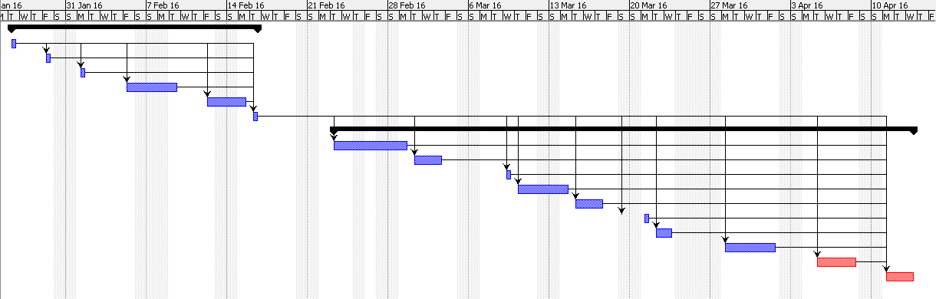
Figure 1. LSC Enrollment System Gantt Chart in MNSTDEV

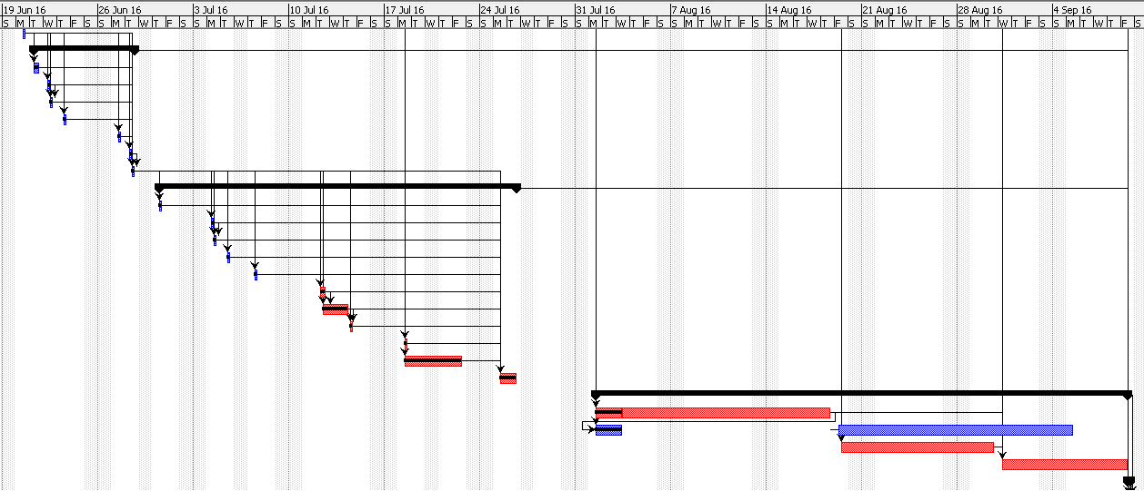
Figure 2. LSC Enrollment System Gantt Chart in MSYSADD

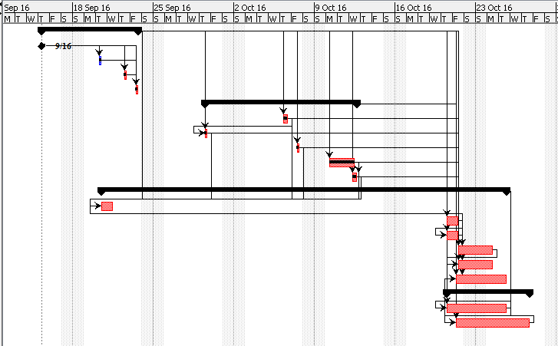

Figure 3. LSC Enrollment System Gantt Chart in MCSPROJ
6. Deliverables
Deliverables specified for the project include:

(i) An acceptable Quality Plan
(ii) An acceptable Data Management Plan
(iii) Scope and Vision Document
(iv) Software Requirement Specification Document
(v) Progress Status Reports
(vi) Project Proposal
(vii) Final Documentation
All project deliverables (the Quality Plan itself, interim reports, progress reports, final reports, publications, maps, data, etc.) should be listed here (and numbered appropriately).

7. Review of Quality Plan

The Project Developer of Loyola Student Center will be required have meeting with their client at least once a month and they should meet their project adviser or project consultant every week in order to review the Quality Plan of their project and at the same time record or track all the changes that has being done to the system.

8. Document and Record Control

Project documentation, records, and data will be controlled and stored under the Asia Pacific College such as APC Wiki Website and under the developers’ documentation repository particularly, Github. All documents relating to the project will be stored in a filing cabinet and with clear and informative labels. All digital files will be stored on the computing network and frequently backed up, either centrally or by the individual member of staff.
The Vision and Scope, Software Requirements Specification, Statement of Work, Quality Plan and Change Management Plan Documentations will be issued to all members of the consortium.
Project Progress Reports will be issued to the following:
Ms. Johanna Joy Limos
Ms. Roselle Wednesday Gardon
Mr. Manuel Sebastian Sanchez

9. Documented Procedures
Give the references of any in-house and/or published methods or procedures used during the project. References need not include the issue/version number, if staff are informed separately of modifications to Procedures. Otherwise, provide a basic resume of methodology with an indication of how it will be archived for future reference. Any centrally administered documents that relate to quality assurance should also be referenced.

10. Additional Information
For the system to be accessed by the staffs, the administrator must approve and limit the activities that the staff will perform. Administrator and developer must conduct a training in handling the system. For the system to be secured, the facility will have an obligation to allocate time and budget for additional software or services to prevent potential risks that the facility might encounter when it comes to system security and maintenance.

Prepared by: Date:
Name

Checked by: Date:
Name

Approved by: Date:
Name

